VENANGO TECHNOLOGY CENTER
JOINT COMMITTEE
1 Vo-Tech Drive
Oil City, Pennsylvania 16301

MINUTES

September 8, 2020

The regular meeting of the Venango Technology Center Joint Committee was held this evening in the Conference Room of the Venango Technology Center, 1 Vo-Tech Drive, Oil City, PA 16301. Mrs. Neely called the meeting to order at seven o’clock (7:00) p.m.

Mrs. Neely asked the members to pause for a moment of silence.

Mrs. Neely asked the members to stand for the pledge of allegiance.

Roll Call: Present: Robert Blauser, Todd Carson, James Come (via phone), James Disque, Jeff Thomas,
Shari Neely

Absent: Troy Johnston, Don Judy, Mark Marterella, Misty Nalepa

Also Present: Mr. Mario Fontanazza, Dr. Lynda Weller

Mrs. Neely stated the Joint Committee members had received copies of the Minutes of the August 3, 2020 meeting in the mail. She asked if there were any additions, corrections or deletions.

Mr. Carson, seconded by Mr. Disque, moved to approve the Minutes of the August 3, 2020 meeting as submitted.

Roll Call: Ayes: Robert Blauser, Todd Carson, James Come (via phone), James Disque, Jeff Thomas,
Shari Neely

Nayes: None, motion carried.

The Treasurer and Secretary’s Report as of 9/8/20 were submitted for information.

Mr. Carson, seconded by Mr. Disque, moved to accept the Treasurer and Secretary’s Report as of 9/8/20 as submitted.

The motion was unanimously approved.

A list of bills from 8/4/20 – 9/8/20 in the amount of $1,179,442.85 was presented for approval.

Mr. Disque, seconded by Mr. Carson, moved to approve the list of bills as presented.

Roll Call: Ayes: Robert Blauser, Todd Carson, James Come (via phone), James Disque, Jeff Thomas,
Shari Neely

Nayes: None, motion carried.

Under Communications, Mr. Fontanazza discussed the Professional Advisory Committee. He also discussed the Calendar of Events for the month of August and the Monthly Enrollment Report as of 9/8/20 were submitted. Mr. Adams discussed the Final report for the 2019-2020 school year and indicated that it had been distributed to the Business Managers.

Mrs. Neely requested approval of the action items as presented. Item 8. a) i.- ix. in one motion.

Mr. Carson, seconded by Mr. Disque, moved to approve action items i.- ix. as follows:

- Recommend approval of the Adult Evening School Schedule for the 2020-2021
school year. (available at the meeting)
- Approve Occupational Advisory Committee members for 2020-2021
- Approve advertising for an instructional aide position. Funding – Perkins
- Approve list of equipment for disposal
- Approve the Title IX personnel; Coordinator – Mario Fontanazza, Investigator – Jena Seidle, Decision – Maker – Pat Adams and Bob Moore – Appeal resolution
- Approve maintenance contract with Renick Brothers for HVAC preventative maintenance for the 20 – 21 year at a cost not to exceed $9,690.00
- Approve contract for CODE HS software not to exceed $2,600.00 – Computer Information Systems
- Approve up to three instructors to attend the Integrated Learning conference if virtual at a cost not to exceed $1,000.00. Funding – Local
- Approve request for Cindy Cornelius to attend the PA association of Practical Nursing
Administrator’s conference if virtual at a cost not to exceed
$1,000.00 – Funding Practical Nursing

Roll Call: Ayes: Robert Blauser, Todd Carson, James Come (via phone), James Disque, Jeff Thomas,
Shari Neely

Nayes: None, motion carried.

Mr. Fontanazza reviewed his Issues/Activities for August 2020

Mr. Adams indicate that a draft of the board policies was in a link on the school website for review.

Upon motion by Mr. Carson, seconded by Mr. Disque, the meeting adjourned at seven seventeen (7:17) p.m.

Recorded by
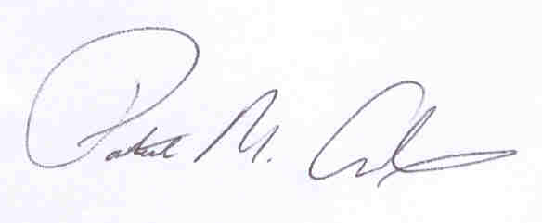
Patrick M. Adams
Secretary, Joint Committee

